**Sprint Burn down Charts**

This documentation primarily documents the sprint charts for our first release. The velocity charts can be viewed on group 25’s Jira if required.

**Sprint 1 – Burn down Chart**

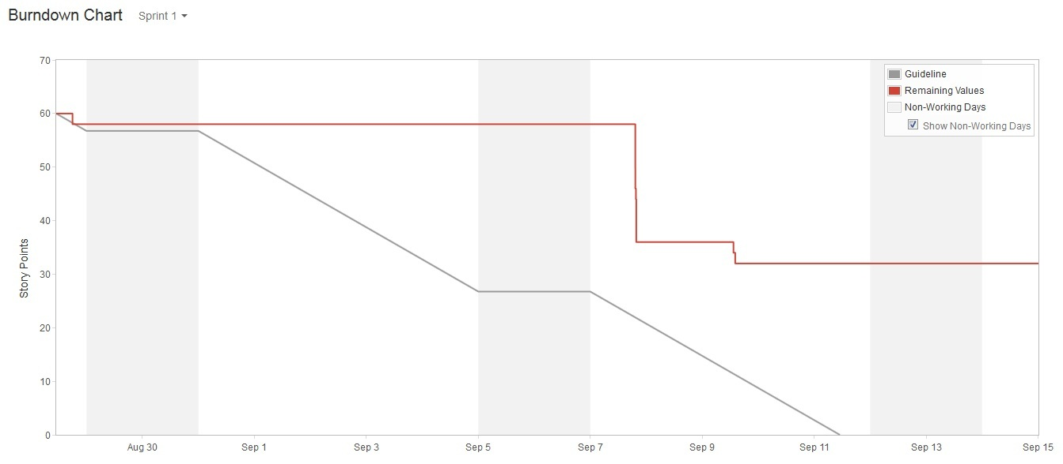

This is the burn down chart for our first sprint. Our first sprint consisted of a total of 28 story points. We were able to complete 28 story points worth of user stories. The burn down chart for this sprint does not show this correctly as the team had issues with using Jira. The flat line at the end accurately shows that we have completed 28 story points out of 60 points. The 60 points was a result of stories from sprint 1 in release 1 combining with user stories in sprint 3 of release 2. We eventually figured this out and have corrected it for sprint 2.

**Sprint 2 – Burn down Chart**

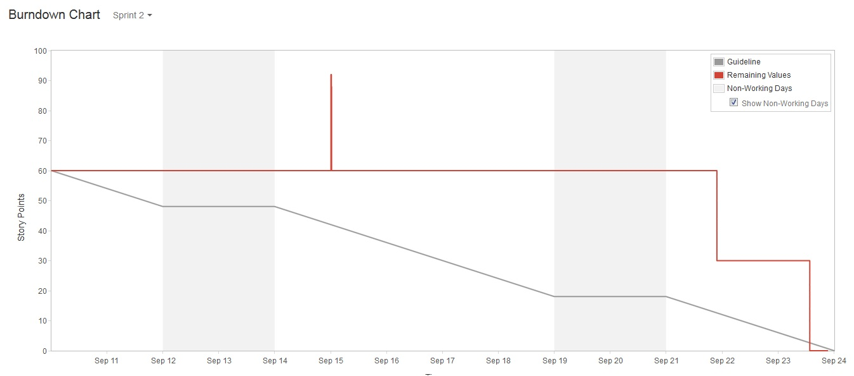

The sprint 2 burn down chart shows better functioning burn down chart. After encountering issues with using Jira for our sprint 1 burn down chart, we have attempted to apply corrections by moving user stories that were not part of sprint 2 into the backlog. The graph now correctly indicates 0 story points left for sprint 2.

The odd peak near the middle of the burn down chart is an artifact caused by the team attempting to fix sprint user story issues relating to the use of Jira.